High Level Design
on

Telecomm Quiz/Tutor Bot

Course Name: Gen AI

Institution Name: Medicaps University – Datagami Skill Based Course

Student Name(s) & Enrolment Number(s):
Sr no | Student Name | Enrolment Number
1. | Mohd Dilshad Khan | EN22CS301602
2. | Nishit Sharma | EN22CS301658
3. | Paridhi Gupta | EN22CS301683
4. | Mohd Suhail Khan | EN22CS301604
5. | Nirmal Kant Shrivastava | EN22CS301656

Group Name: Group 08D6
Project Number:GAI-19
Industry Mentor Name:
University Mentor Name: Prof. Ajaj Khan
Academic Year:2025-2026

Table of Contents
- Introduction.
  - Scope of the document
1.2. Intended Audience
1.3. System overview.
- System Design.
  - Application Design
  - Process Flow.
  - Information Flow.
  - Components Design
2.5. Key Design Considerations
2.6. API Catalogue.
- Data Design.
  - Data Model
  - Data Access Mechanism
  - Data Retention Policies
  - Data Migration
- Interfaces
- State and Session Management
- Caching
- Non-Functional Requirements
  - Security Aspects
  - Performance Aspects
- References

1. Introduction
The Telecom Quiz/Tutor Bot is an AI-powered learning system designed to enhance users’ understanding of telecom concepts through interactive quizzes and intelligent assistance. The system leverages advanced technologies such as Large Language Models (LLMs) to evaluate user responses and provide meaningful feedback.
Unlike traditional quiz platforms, this system offers contextual answer evaluation, personalized learning, and real-time assistance through a chatbot. It enables users to learn telecom topics such as mobile plans, network technologies, and data services in an engaging and efficient manner.
The system is built using a scalable architecture that includes a frontend interface, backend services, AI processing layer, and data storage components. It ensures smooth interaction between users and AI services, providing accurate responses and performance insights.
This High-Level Design (HLD) document presents the overall architecture, system components, data flow, and key design considerations of the Telecom Quiz/Tutor Bot.

Scope of the Document
This document provides the High-Level Design (HLD) of the Telecom Quiz/Tutor Bot system. It outlines the overall system architecture, major components, and the interactions between different layers of the application.
The document covers:
- The architectural design of the system
- High-level application flow and user interaction
- Integration of AI components such as Large Language Models (LLMs)
- Data handling and storage mechanisms
- Key design considerations including scalability, performance, and security
- Interfaces and communication between system components
The scope of this document is limited to the conceptual and architectural design of the system. It does not include detailed implementation logic, code-level design, or low-level specifications.

1.2 Intended Audience
This document is intended for all stakeholders involved in the design, development, and evaluation of the Telecom Quiz/Tutor Bot system.
It is useful for:
- System Architects – To understand the overall architecture and design decisions of the system.
- Developers – To get a high-level understanding of system components and their interactions.
- AI Engineers – To understand how Large Language Models (LLMs) are integrated into the system.
- Project Evaluators / Faculty – To assess the system architecture, scalability, and design approach.
- Project Team Members – To ensure a common understanding of the system structure and workflow.

1.3 System Overview
The Telecom Quiz/Tutor Bot is an AI-based system designed to provide an interactive and intelligent learning experience in the telecom domain. The system allows users to attempt quizzes on telecom topics such as mobile plans, data usage, and network technologies, and receive instant feedback on their responses.
At a high level, the system consists of a frontend interface, backend services, an AI processing layer, and data storage components. The frontend enables users to interact with the system through quizzes and chatbot queries. The backend handles request processing, routing, and communication with AI services.
The AI processing layer integrates a Large Language Model (LLM) to evaluate user answers and generate contextual feedback. It also powers the chatbot by generating accurate and context-aware responses using information retrieved from a vector database.
The system is designed to support real-time interaction, scalable usage, and modular expansion. It ensures smooth communication between components to deliver personalized learning, intelligent evaluation, and efficient query handling.

2. System Design
The system design of the Telecom Quiz/Tutor Bot defines the overall architecture and interaction between major components of the application. The system follows a layered and modular architecture to ensure scalability, flexibility, and maintainability.
The architecture consists of four primary layers: the presentation layer, application layer, AI processing layer, and data layer. The presentation layer provides the user interface for quiz interaction and chatbot communication. The application layer handles request processing, routing, and coordination between different services.
The AI processing layer integrates a Large Language Model (LLM) to perform intelligent answer evaluation and generate chatbot responses. The data layer manages storage of quiz data, user performance, and knowledge base information using both traditional databases and vector databases.
These components work together to enable real-time interaction, personalized feedback, and efficient data handling within the system.

2.1 Application Design
The Telecom Quiz/Tutor Bot is designed using a layered architecture to ensure scalability, modularity, and efficient interaction between system components.
- Presentation Layer
This layer provides the user interface for interaction. Users can attempt quizzes, view results, and interact with the chatbot through a web-based interface.
- Application Layer
This layer manages business logic and request handling. It processes user inputs, routes requests to appropriate services, and coordinates communication between different components.
- AI Processing Layer
This layer integrates a Large Language Model (LLM) to evaluate quiz answers and generate chatbot responses. It ensures intelligent and context-aware processing of user inputs.
- Data Layer
This layer handles storage and retrieval of data, including quiz questions, user performance, and telecom knowledge. It uses both traditional databases and vector databases for efficient data management.
The layered design ensures clear separation of responsibilities, making the system scalable, maintainable, and easy to extend.

2.2 Process Flow
The process flow of the Telecom Quiz/Tutor Bot describes how user interactions are handled across the system at a high level.
When a user accesses the system, they can choose between quiz mode or chatbot mode. In quiz mode, the system retrieves relevant questions from the data layer and presents them to the user. Once the user submits an answer, the request is processed by the application layer and forwarded to the AI processing layer. The Large Language Model (LLM) evaluates the response and generates feedback, which is then returned to the user along with the score.
In chatbot mode, the user submits a query through the interface. The application layer processes the request and retrieves relevant context from the data layer, particularly the vector database. The query and context are then passed to the AI processing layer, where the LLM generates a response. The response is returned to the user through the interface.
This process flow ensures smooth communication between system components and enables real-time, intelligent interaction.
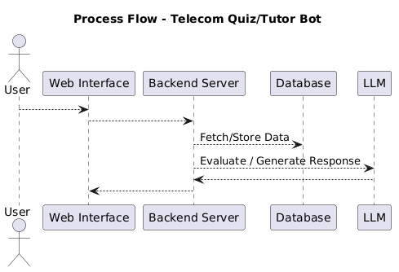

2.3 Information Flow
The information flow in the Telecom Quiz/Tutor Bot describes how data moves between different layers of the system during user interaction.
When a user interacts with the system through the web interface, the request is sent to the backend server. In quiz mode, user answers are processed by the backend and forwarded to the AI processing layer for evaluation. The Large Language Model (LLM) analyzes the response and returns feedback along with a score, which is then sent back to the user interface.
In chatbot mode, the user query is sent to the backend, which retrieves relevant information from the data layer, especially the vector database. This information is combined with the query and passed to the LLM to generate a response. The generated response is then returned to the user.
Thus, information flows continuously between the presentation layer, application layer, AI processing layer, and data layer, enabling real-time processing and intelligent responses.
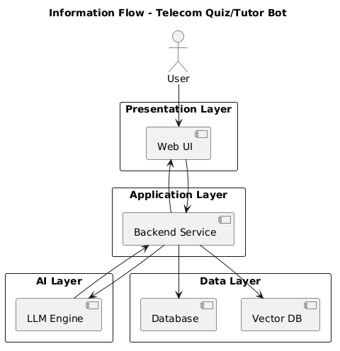

2.4 Component Design
The Telecom Quiz/Tutor Bot system is composed of several high-level components that work together to provide an intelligent and interactive learning experience.
1. Presentation Component
- Provides the user interface for interaction.
- Includes quiz interface, chatbot interface, and result display.
- Handles user inputs and displays system responses.
2. Application Component (Backend Service)
- Acts as the central controller of the system.
- Handles request processing, routing, and communication between components.
- Ensures smooth data flow across the system.

3. AI Component (LLM Engine)
- Performs intelligent processing of user inputs.
- Evaluates quiz answers and generates feedback.
- Handles chatbot queries and produces context-aware responses.
4. Data Component
- Stores quiz questions, user data, and results.
- Maintains structured data required for system operations.
5. Knowledge Base Component (Vector Database)
- Stores telecom-related knowledge and embeddings.
- Supports retrieval of relevant context for chatbot responses.
6. External Service Component
- Represents third-party AI services such as LLM APIs (OpenAI/Gemini).
- Provides advanced natural language understanding and generation capabilities.asdd

2.5 Key Design Considerations

The Telecom Quiz/Tutor Bot system is composed of several high-level components that work together to provide an intelligent and interactive learning experience.

1. Presentation Component

Provides the user interface for interaction.

Includes quiz interface, chatbot interface, and result display.

Handles user inputs and displays system responses.

2. Application Component (Backend Service)

Acts as the central controller of the system.

Handles request processing, routing, and communication between components.

Ensures smooth data flow across the system.

3. AI Component (LLM Engine)

Performs intelligent processing of user inputs.

Evaluates quiz answers and generates feedback.

Handles chatbot queries and produces context-aware responses.

4. Data Component

Stores quiz questions, user data, and results.

Maintains structured data required for system operations.

5. Knowledge Base Component (Vector Database)

Stores telecom-related knowledge and embeddings.

Supports retrieval of relevant context for chatbot responses.

6. External Service Component

Represents third-party AI services such as LLM APIs (OpenAI/Gemini).

Provides advanced natural language understanding and generation capabilities.

2.6 API Catalogue
The Telecom Quiz/Tutor Bot exposes a set of high-level REST APIs that enable communication between the frontend and backend services. These APIs handle quiz operations, answer evaluation, and chatbot interactions.
1. GET /
Returns system status and basic information.
Description:
Used to check whether the system is active and running.
2. GET /questions
Fetches quiz questions based on selected topic.
Description:
Retrieves a list of questions from the data layer for the user to attempt.
3. POST /submit_answer
Submits user answer for evaluation.
Description:
Sends the user’s response to the backend, which forwards it to the AI processing layer for evaluation and feedback generation.
4. POST /chat
Handles chatbot queries.
Description:
Processes user queries and returns AI-generated responses using LLM and knowledge base.
5. GET /result
Returns user performance details.
Description:
Provides summary of user scores, accuracy, and feedback.

3. Data Design

3.1 Data Model
The data model of the Telecom Quiz/Tutor Bot defines how data is structured, stored, and managed within the system. It includes entities related to users, quiz content, responses, and knowledge storage.
The system uses a combination of structured data storage (relational database) and unstructured data storage (vector database).
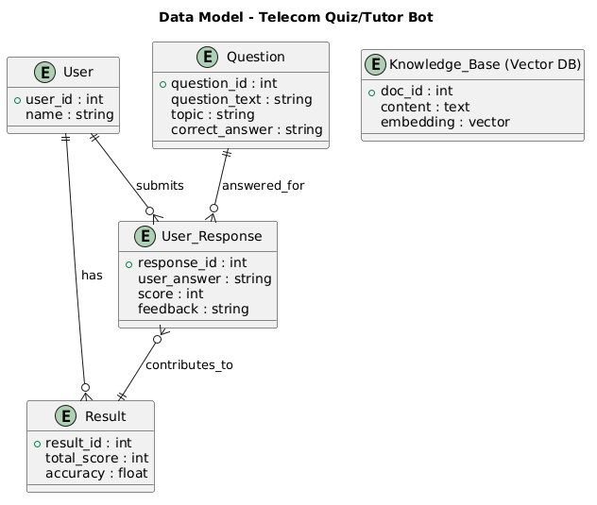

3.2 Data Access Mechanism
The Telecom Quiz/Tutor Bot uses a structured and efficient data access mechanism to manage interactions between the application and data storage systems.
The backend application layer acts as the central point for all data operations. It communicates with the relational database to perform operations such as retrieving quiz questions, storing user responses, and maintaining performance records. Standard database queries and ORM-based access methods are used to ensure efficient and secure data handling.
For chatbot functionality, the system interacts with a vector database to retrieve relevant context based on user queries. Semantic search techniques are used to fetch the most relevant information, which is then passed to the AI processing layer for response generation.
All data access operations are performed through controlled APIs, ensuring data consistency, integrity, and security. This approach enables efficient data retrieval and supports real-time processing within the system.

3.3 Data Retention Policies
The Telecom Quiz/Tutor Bot system follows structured data retention policies to ensure efficient data management, system performance, and data integrity. These policies define how long different types of data are stored, how they are maintained, and when they are removed or archived.
User-related data, including responses, scores, and performance metrics, is retained for a specific duration to support personalized learning and progress tracking. This data allows the system to provide meaningful feedback, analyze user performance, and improve the overall learning experience. However, to avoid unnecessary storage usage, older or inactive user data may be periodically archived or deleted based on predefined retention rules.
Quiz-related data, such as questions, topics, and correct answers, is considered core system data and is retained for long-term use. This ensures consistency in quiz delivery and allows the system to reuse and update content as needed. Any updates to quiz content are managed carefully to maintain data accuracy and relevance.
For chatbot functionality, the system maintains a knowledge base within a vector database. This data includes telecom-related information converted into embeddings for efficient semantic search. The knowledge base is regularly updated to ensure that the chatbot provides accurate and up-to-date responses. Outdated or irrelevant data may be replaced to maintain quality.
The system also ensures that only necessary data is stored, minimizing redundancy and optimizing storage efficiency. Data cleanup processes may be scheduled to remove temporary or unused data, improving system performance.

3.4 Data Migration
Data migration in the Telecom Quiz/Tutor Bot refers to the process of transferring data across different systems, databases, or environments while ensuring data consistency and reliability. This is essential during system upgrades, database changes, or deployment across development, testing, and production environments.
Structured data such as user details, quiz questions, responses, and performance records can be migrated using standard database migration tools and scripts. These tools help in transferring data efficiently while maintaining schema consistency and data integrity.
For AI-related components, the knowledge base stored in the vector database may also require migration. Since this data consists of embeddings, migration may involve transferring existing embeddings or regenerating them to ensure compatibility with the new environment.
To prevent data loss, backup mechanisms are implemented before migration. After migration, validation checks are performed to ensure that all data has been accurately transferred and is functioning correctly within the system.
The migration process is typically carried out in a controlled and phased manner to minimize system downtime. Automated scripts and version-controlled database schemas help reduce errors and ensure smooth transitions.
Overall, the data migration strategy ensures reliable data transfer while maintaining system performance, consistency, and availability.

4. Interfaces
The Telecom Quiz/Tutor Bot includes multiple interfaces for smooth communication between users and system components:
- User Interface (UI)
  - Web-based interface for user interaction
  - Allows quiz attempts, chatbot queries, and result viewing
- Frontend–Backend Interface
  - Communication via RESTful APIs
  - Sends user inputs (answers/queries) to backend
  - Receives responses (scores, feedback, chatbot replies)
- Backend API Interface
  - Handles request processing and routing
  - Connects frontend with AI services and data layer
- AI Service Interface (LLM API)
  - Connects backend to external LLM services (OpenAI/Gemini)
  - Used for answer evaluation and chatbot response generation
- Database Interface
  - Connects backend with relational database
  - Used for storing questions, user data, and results
- Vector Database Interface
  - Connects backend with vector database
  - Used for retrieving context for chatbot (RAG approach)

5. State and Session Management
The Telecom Quiz/Tutor Bot manages user state and sessions to ensure smooth and consistent interaction across the system.
- Stateless Backend Design
  - The backend APIs are designed to be stateless.
  - Each request contains all necessary information for processing.
- Session Handling
  - User sessions are managed using session IDs or tokens.
  - Ensures continuity during quiz attempts and chatbot interactions.
- User State Tracking
  - Tracks user progress such as current question, score, and responses.
  - Enables resuming quizzes and maintaining interaction flow.
- Token-Based Authentication (Optional)
  - Uses tokens (e.g., JWT) to identify and authenticate users.
  - Ensures secure access to system features.
- Temporary Data Storage
  - Session data may be stored temporarily in memory or cache.
  - Used for quick access during active sessions.
- Persistence of Important Data
  - Final results, scores, and user performance are stored in the database.
  - Ensures long-term tracking and analysis.
- Session Expiry
  - Sessions expire after a period of inactivity.
  - Helps in maintaining security and resource optimization.

6. Caching
Caching is used in the Telecom Quiz/Tutor Bot to improve system performance and reduce response time by temporarily storing frequently accessed data.
- Purpose of Caching
  - Reduces latency and improves user experience
  - Minimizes repeated database and API calls
- Quiz Data Caching
  - Frequently used questions and topics can be cached
  - Reduces database load during quiz sessions
- Chatbot Response Caching
  - Common queries and responses can be cached
  - Avoids repeated calls to the LLM for similar queries
- Session Data Caching
  - Temporary user session data (current progress, answers) can be stored in cache
  - Enables faster access during active sessions
- Technology Options
  - In-memory caching (e.g., Redis) for fast data retrieval
  - Local caching for small-scale applications
- Cache Expiry (TTL)
  - Cached data is stored for a limited time
  - Ensures updated and relevant information
- Benefits
  - Improves system performance
  - Reduces computational cost

7. Non-Functional Requirements

7.1 Security Aspects
The Telecom Quiz/Tutor Bot system incorporates several security measures to protect user data and ensure safe system operation.
- Authentication and Authorization
  - Users can be authenticated using secure methods such as token-based authentication (e.g., JWT).
  - Access to system features is controlled based on user roles.
- Data Protection
  - Sensitive user data is stored securely in the database.
  - Encryption techniques can be used to protect data at rest and in transit.
- Input Validation
  - All user inputs are validated to prevent malicious data entry.
  - Helps protect against attacks such as SQL injection and script injection.
- Secure API Communication
  - APIs are accessed through secure protocols (HTTPS).
  - Ensures safe data transmission between client and server.
- Access Control
  - Restricted access to backend services and databases.
  - Only authorized components can interact with critical resources.
- Error Handling
  - System avoids exposing sensitive information in error messages.
  - Prevents leakage of internal system details.
- Session Security
  - Secure session management with expiration mechanisms.
  - Prevents unauthorized access through inactive sessions.

7.2 Performance Aspects
The Telecom Quiz/Tutor Bot is designed to ensure efficient performance and fast response times for a smooth user experience.
- Low Response Time -The system is optimized to provide quick responses for quiz evaluation and chatbot interactions.
- Efficient API Handling -FastAPI enables high-performance request processing and supports concurrent requests.
- Caching Mechanism -Frequently accessed data such as quiz questions and common chatbot responses can be cached to reduce latency.
- Optimized LLM Usage -AI calls are optimized to reduce unnecessary requests and improve response speed.
- Scalability Support -The system can handle multiple users simultaneously without performance degradation.
- Database Optimization -Efficient queries and indexing are used for faster data retrieval.

8. References
- FastAPI Documentation. https://fastapi.tiangolo.com/
- MongoDB Documentation. https://www.mongodb.com/docs/
- LangChain Documentation. https://docs.langchain.com/
- Devlin, J. et al. (2018). BERT: Pre-training of Deep Bidirectional Transformers for Language Understanding. arXiv:1810.04805.
- Lewis, P. et al. (2020). Retrieval-Augmented Generation for KnowledgeIntensive NLP Tasks. arXiv:2005.11401.
- OpenAI API Documentation. https://platform.openai.com/docs
- Google Gemini API Documentation – https://ai.google.dev/
- Python Official Documentation – https://docs.python.org/3/

